EMSO EVOLVE
KOM Logistics & Practical Information GUIDE
Meeting Venue, Logistics & Social Programme (6–8 October)

6 - 8 OCTOBER
EMSO EVOLVE Kick Off Meeting
• Location: Hotel Genova Rome (Meeting Room)
• Address: Via Cavour 25, 00184 Rome, Italy
• Note: All working sessions and event meetings will take place at Hotel Genova.

📍 MAIN MEETING VENUE
Hotel Genova Rome (link for further information)
Via Cavour 25, 00184 Rome, Italy (Near Roma Termini Railway Station)
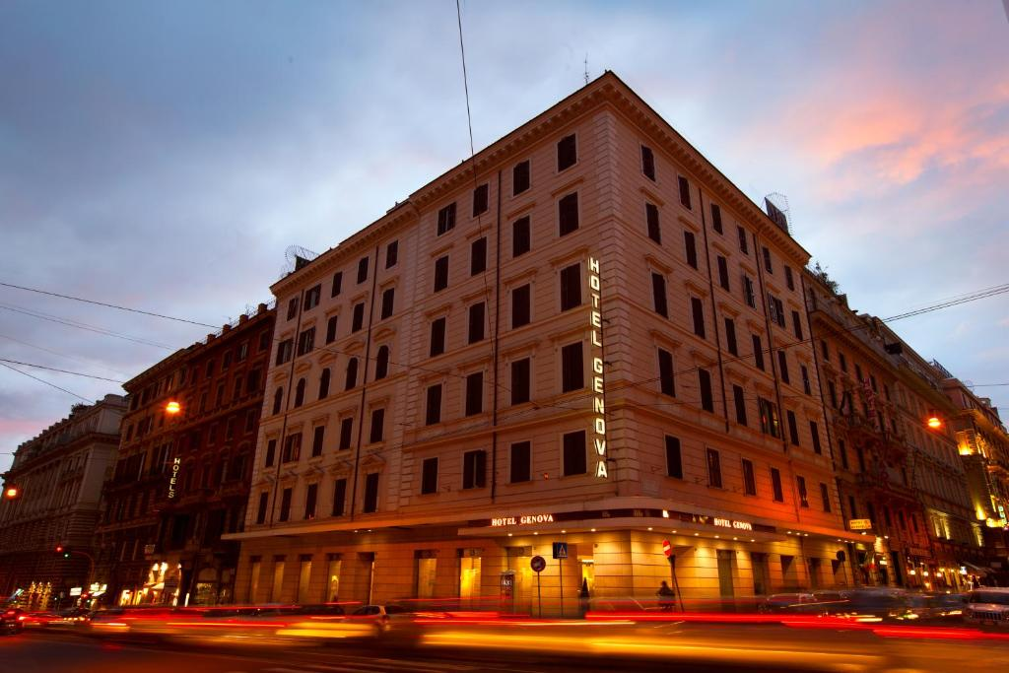

Travel Options:
- From Roma Termini Railway Station:
On Foot: The hotel is approximately a 5-minute walk from Roma Termini. Head southwest on Via Cavour directly toward the venue (map below).
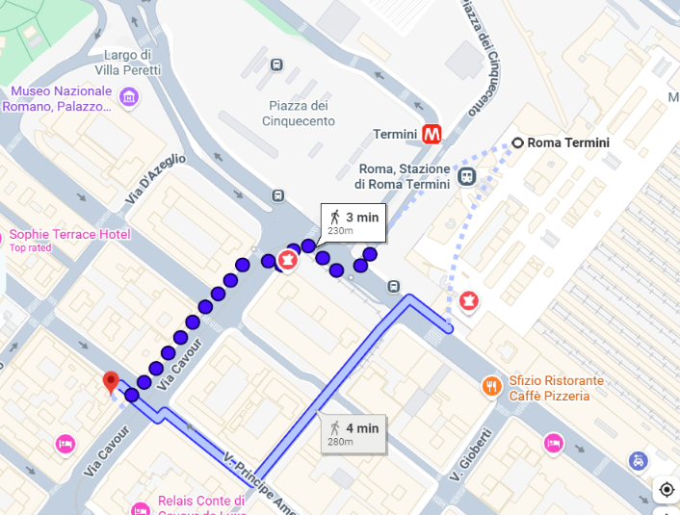

- From Rome Fiumicino Airport:
Leonardo Express Train: From the train station inside Rome Fiumicino Airport, take the direct train to Roma Termini (departures every 15–30 minutes, travel time approx. 30 minutes). From Termini station, the hotel is just a 5-minute walk away.
Taxi: Travel time from Rome Fiumicino Airport is approximately 30–45 minutes depending on traffic. The fixed regulated taxi fare from Fiumicino to Rome city center is usually €50.

6 OCTOBER
Guided Walking Tour of Historic Rome

• Duration: Approx. 1 hour (Organized by Viaggi dell’Elefante)
• Meeting Time: 6:30pm CEST
• Meeting Point: In front of Gelateria Flor – Via Cavour 337, Rome (A short walk from Hotel Genova)
• Tour Route: Piazza Venezia ➔ Via dei Fori Imperiali ➔ Colosseum (exterior)
• End Point: Terrazze del Colosseo at 8:00pm CEST

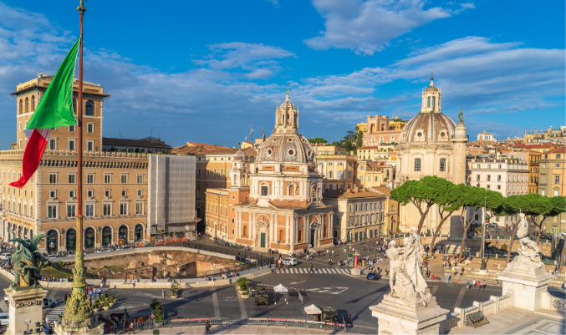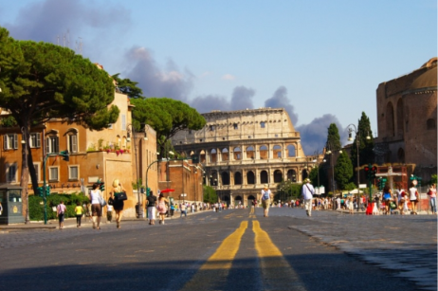

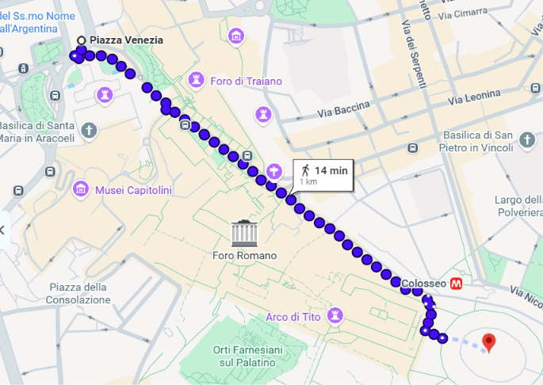

6 OCTOBER
Social Aperitif-Dinner at Terrazze al Colosseo
• Time: 8:00pm CEST
• Venue: Room Mate Collection Mia, Rome Colosseum (Terrazze al Colosseo)
• Address: Via Capo d'Africa 54, 00184 Rome, Italy

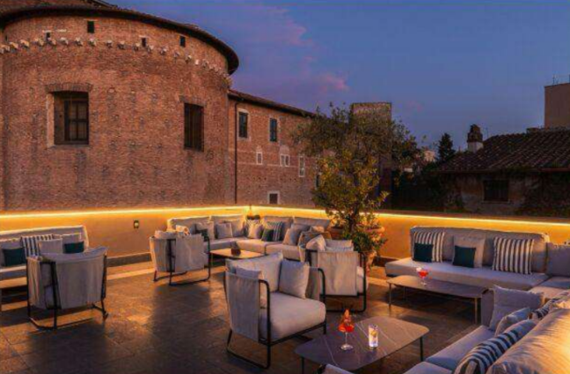

7 OCTOBER
Working Dinner

• Time: 7:30pm CEST
• Venue: Osteria Il Bocconcino
• Address: Via Ostilia 23, 00184 Rome, Italy (Colosseum area)

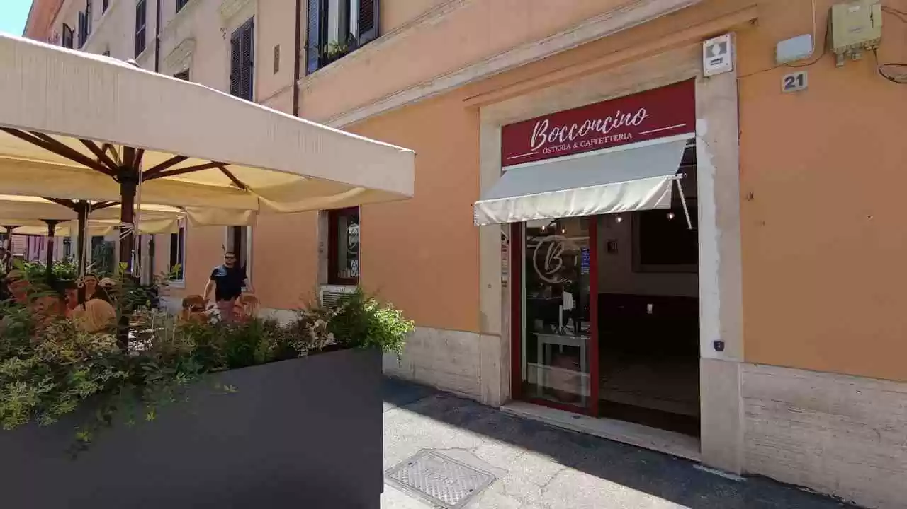

—------------------------------------------------------------------------------------------------------------------------—--------

For any urgent needs or in case of emergency during the meeting, please contact:
Valentina Tegas at +39 340 5951858

